1. Create numeric, character, and logical vectors and display type and content.

Aim:
To create numeric, character, and logical vectors and display type and content.

Procedure:
Step 1: Open RStudio or R console on your system.
Step 2: Create a numeric vector containing numerical values. Step
3: Display the contents of the numeric vector on the screen.
Step 4: Use the class function to check and print the data type of the numeric vector.
Step 5: Create a character vector containing names or text values.
Step 6: Display the contents of the character vector.
Step 7: Use the class function to identify and print the data type of the character vector. Step
8: Create a logical vector containing TRUE and FALSE values.
Step 9: Display the logical vector on the screen.
Step 10: Use the class function to print the data type of the logical vector.
Step 11: Observe and note that numeric, character, and logical vectors each have distinct datatypes
INPUT AND OUTPUT SCREEN SHOT:
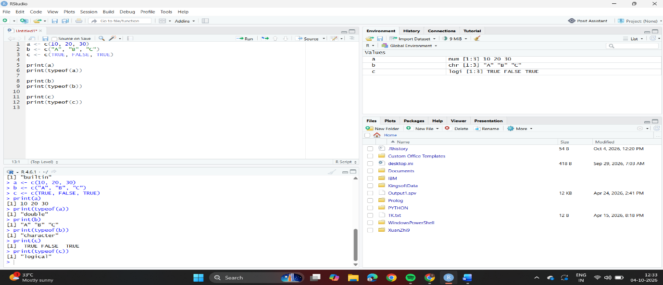
Result:
Hence the output is verified successfully.

2. Create labeled matrices (5×4, 3×3, 2×2) filled by row/column.

Aim:
To create labeled matrices (5×4, 3×3, 2×2) filled by row/column.

Procedure:
Step 1: Open RStudio or R console on your system.
Step 2: Create a matrix by arranging a sequence of numbers into rows and columns.
Step 3: Display the created matrix to check its elements and layout.
Step 4: Create another matrix with a different size (for example, 3×3) to understand
matrix creation with various dimensions.
Step 5: Display the second matrix to verify its arrangement.
Step 6: Create a smaller matrix (for example, 2×2) to observe how matrix size can vary.
Step 7: Display the third matrix to view its content.
Step 8: Observe that each matrix organizes elements in a rectangular form with equal-
length rows and columns.

INPUT AND OUTPUT SCREEN SHOT:
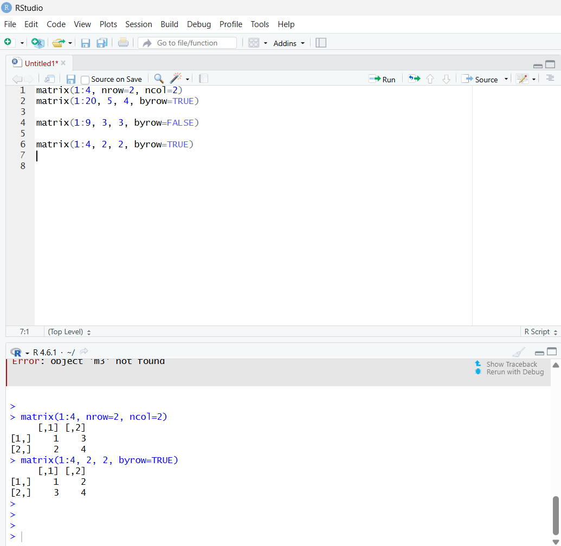

Result:
Hence the output is verified successfully.

3. Write an R program to create and display a 3D array with specified rows,
columns, and tables.

Aim:
To write an R program to create and display a 3D array with specified rows, columns, and tables.
Procedure:
Step 1: Open RStudio or R console on your computer.
Step 2: Create a sequence of numbers to be stored in a variable.Step 3: Use that sequence to create a multi-dimensional array by specifying dimensions suchas number of rows, columns, and tables.Step 4: Store the created array in a variable.
Step 5: Display the array to view all the elements arranged across multiple rows,
columns, and layers.Step 6: Observe how an array in R can store data in more than two dimensions, unlike a
matrix.
INPUT AND OUTPUT SCREEN SHOT:
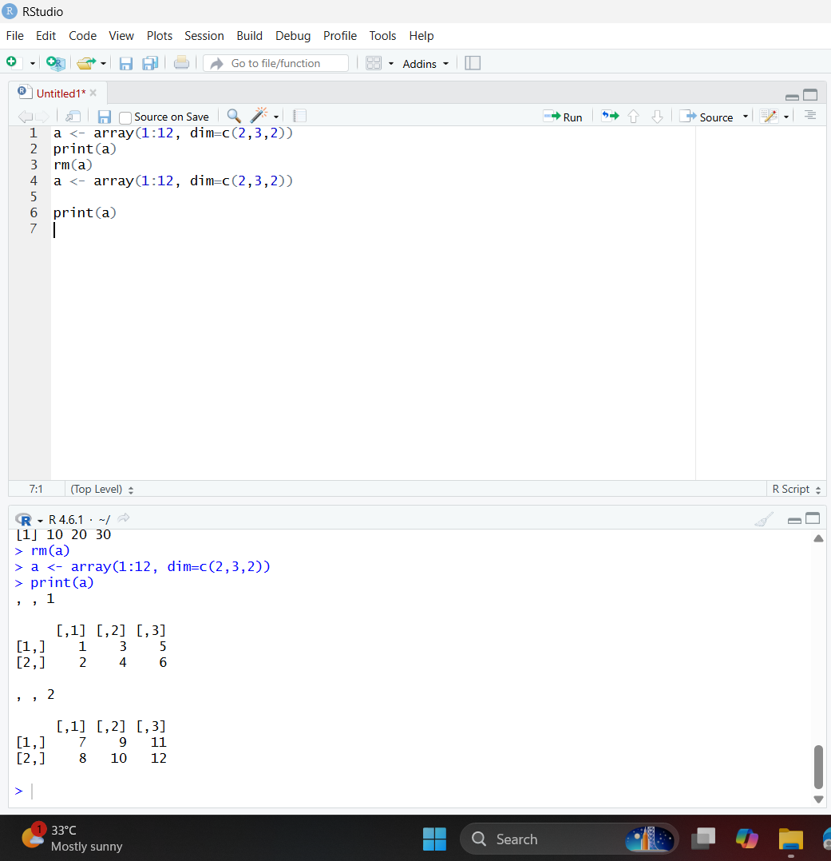

4. Create arrays from vectors with dimension names, print specific elements.

Aim:
To create arrays from vectors with dimension names, print specific elements.

Procedure:
Step 1: Open RStudio or R console on your system.
Step 2: Create a sequence of numbers and store it in a variable.
Step 3: Use the array function to arrange these numbers into multiple dimensions by
specifying the number of rows, columns, and tables.
Step 4: Store the created array in a variable.
Step 5: Display the entire array to view how the elements are arranged in each layer.
Step 6: Access a specific element from the array using its row, column, and table
position.
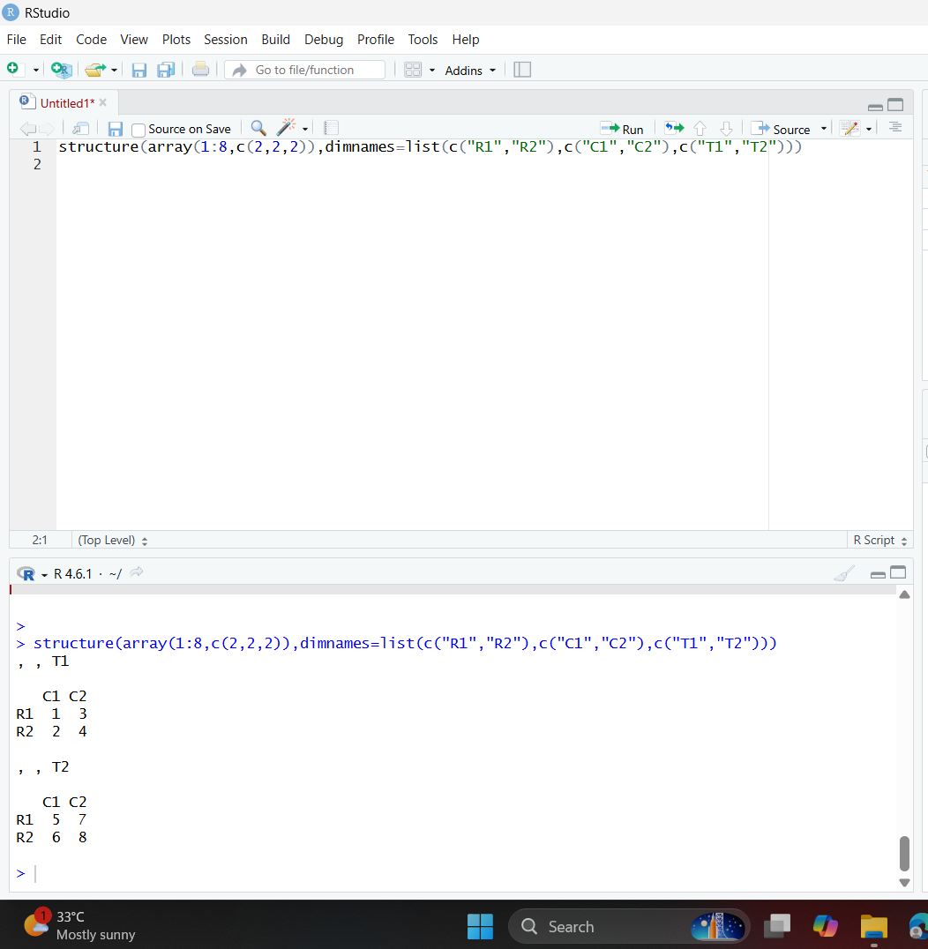
5. Create and manipulate factor variables (e.g., women’s dataset heights, random
LETTERS sample).

Aim:
Create and manipulate factor variables (e.g., women’s dataset heights, random LETTERS
sample).

Procedure:
Step 1: Open RStudio or R console on your computer.
Step 2: Create a character vector containing categorical values such as height levels.
Step 3: Convert the character vector into a factor to represent it as categorical data.
Step 4: Display the factor to observe that R assigns internal numeric codes to each
category.
Step 5: Set a random seed value to ensure that the random sampling results remain the
same each time you run the program.
Step 6: Randomly generate a sample of leflers from A to E using the sample function.
Step 7: Convert the generated leflers into a factor to represent them as categorical
variables.
Step 8: Print the factor to view 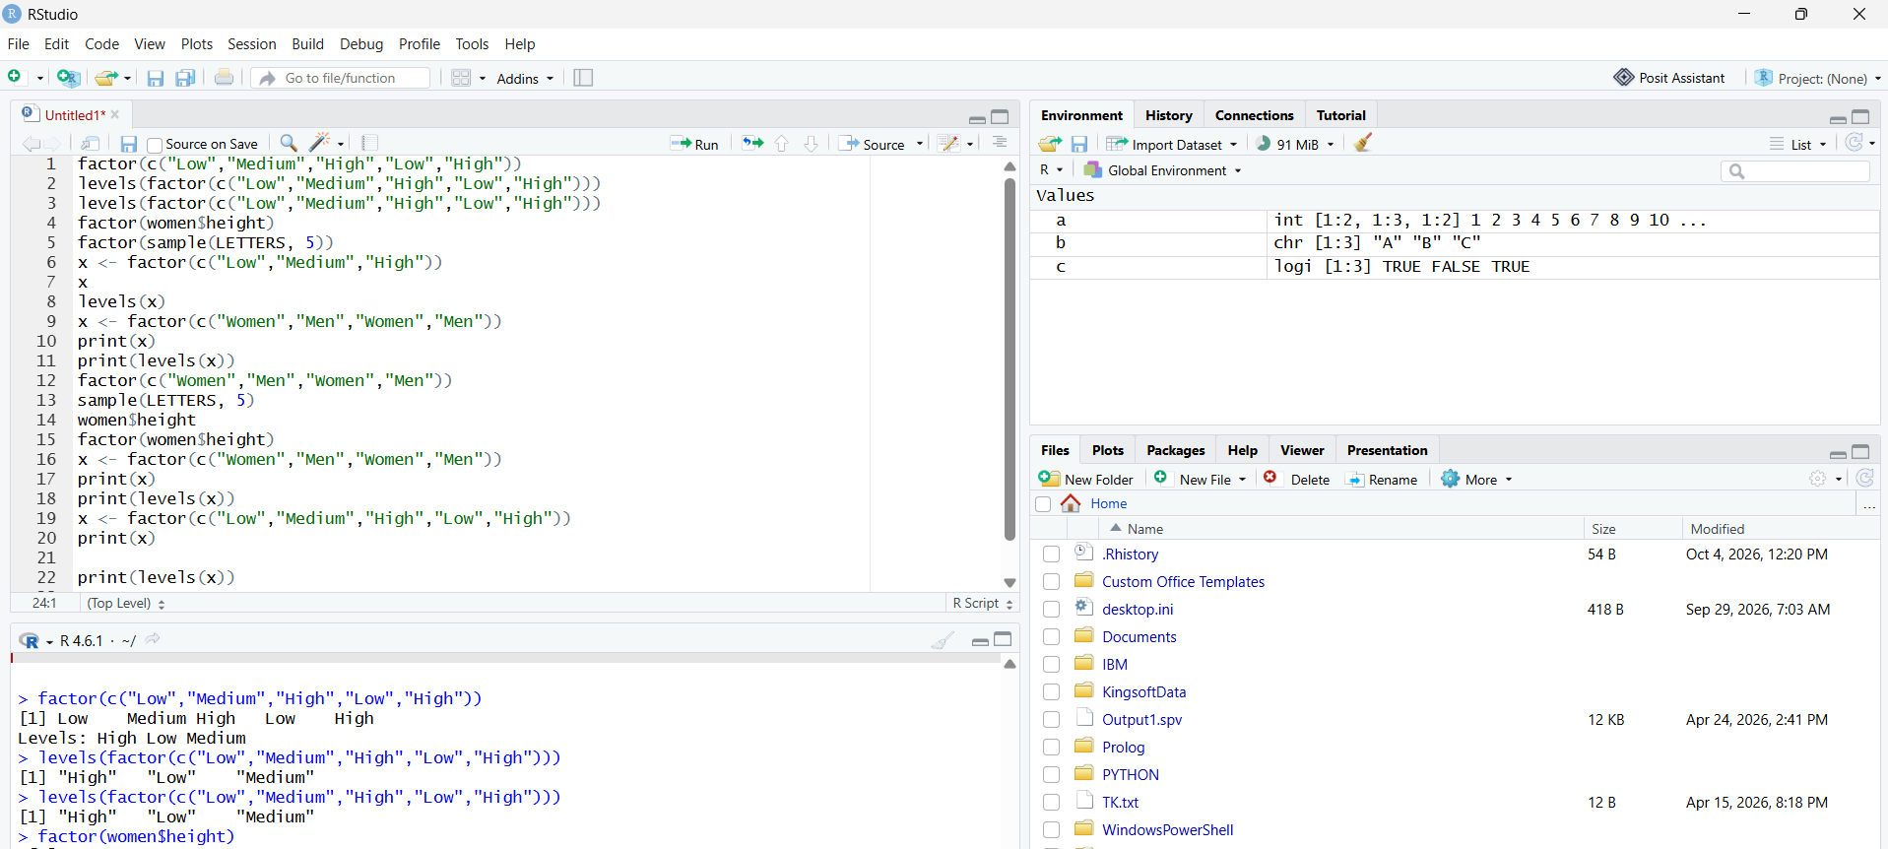
6. Create an R list containing vectors, matrices, and functions; display contents.

Aim:
To create an R list containing vectors, matrices, and functions; display contents.

Procedure
Step 1: Open RStudio or R console on your system.
Step 2: Create a numeric vector and store it in a variable.
Step 3: Create a matrix by arranging numbers into specified rows and columns.
Step 4: Define a simple function that performs a mathematical operation (for example,
squaring a number).
Step 5: Combine the vector, matrix, and function into a single list using the list function.
Step 6: Assign appropriate names to each component in the list for befler readability.
Step 7: Display the list to view all its components — the vector, matrix, and function —
stored together in one structured object.
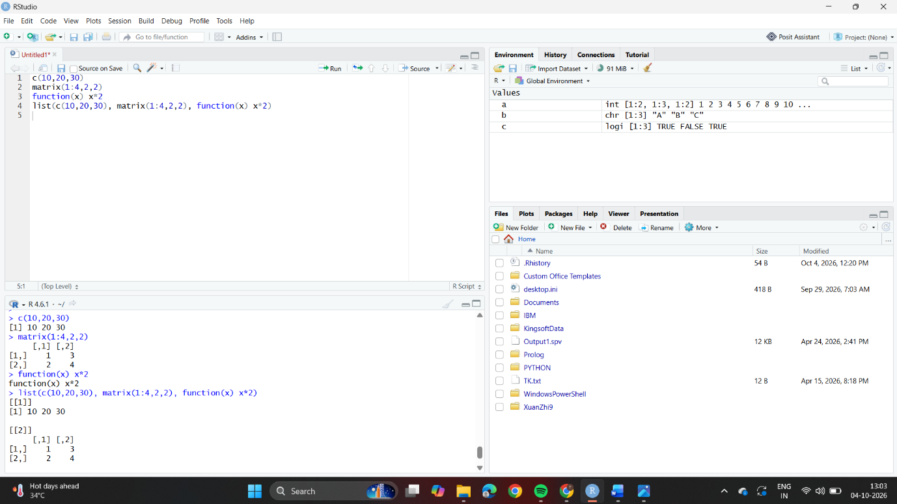
7. Write R programs for basic tasks: Factors of a number, generate a vector of 10
random integers between -50 and 50, print numbers 1–100 with FizzBuzz logic.

Aim:
To write R programs for basic tasks: Factors of a number, generate a vector of 10 random
integers between -50 and 50, print numbers 1–100 with FizzBuzz logic.

Procedure
Step 1: Open RStudio or R console on your system.
Step 2: Assign an integer value to a variable to represent the number for which factors are to
be found.
Step 3: Initialize an empty integer vector to store the factors.
Step 4: Use a for loop to iterate through all numbers from 1 to the given number.
Step 5: Inside the loop, use the modulus operator to check if the number divides evenly
(remainder equals 0).
Step 6: If the condition is true, append that value to the factors vector. Step
7: After the loop completes, print all the factors of the given number.
Step 8: Set a random seed to ensure the random number generation gives reproducible
results.
Step 9: Generate and print 10 random integers within a specified range (−50 to 50).
Step 10: Use another for loop to iterate from 1 to 100 and apply the FizzBuzz logic:
Print “FizzBuzz” for numbers divisible by both 3 and 5.
Print “Fizz” for numbers divisible only by 3.
Print “Buzz” for numbers divisible only by 5.
Otherwise, print the number itself.
Step 11: Display the complete sequence of printed outputs to verify the logic.
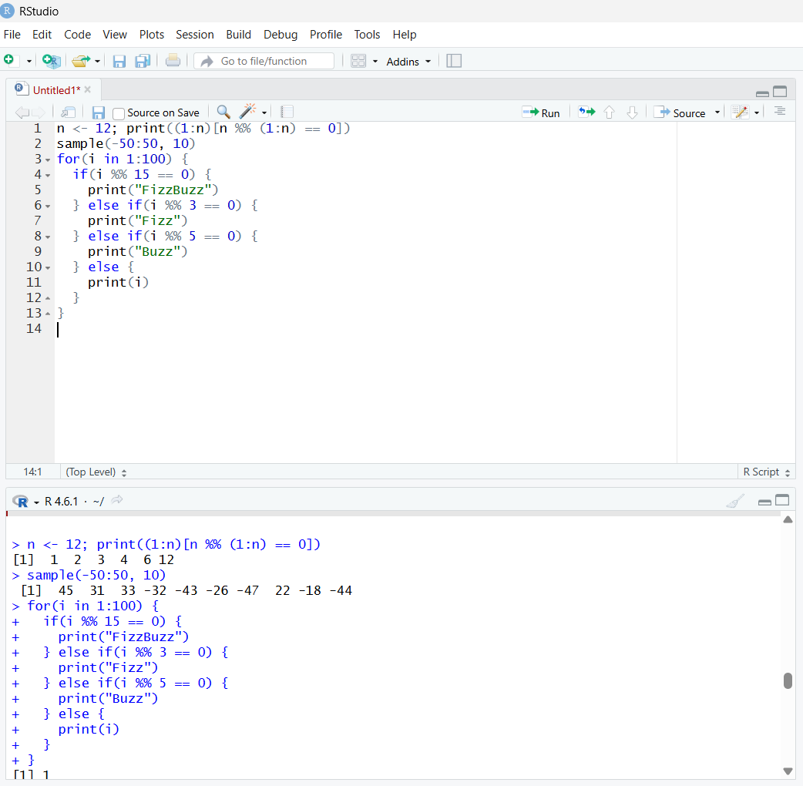
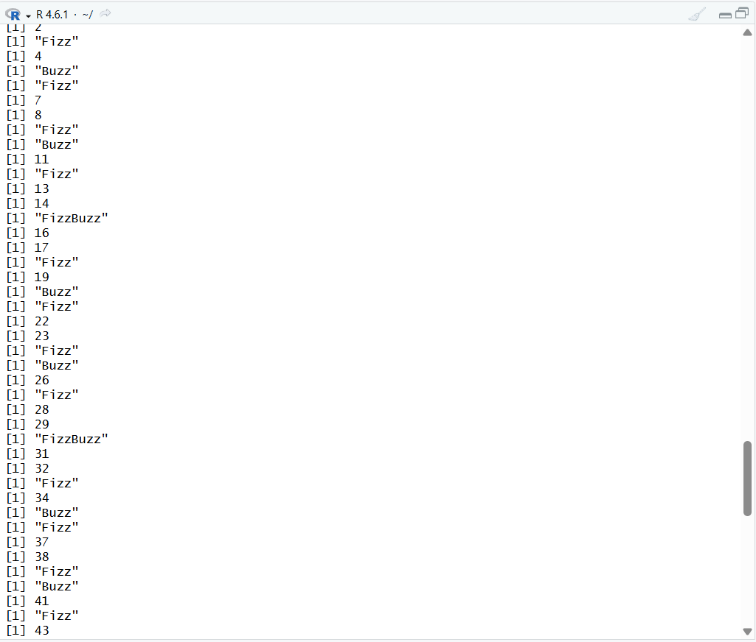
8. Generate random numbers from a normal distribution; count occurrences.

Aim:
To generate random numbers from a normal distribution; count occurrences.

Procedure:
Step 1: Open RStudio or R console on your computer.
Step 2: Set a random seed value to make the random results reproducible every time you
run the program.
Step 3: Generate a set of random numbers from a normal distribution using the rnorm
function.
Step 4: Round the generated random numbers to the nearest whole number to group
similar values.
Step 5: Use the table function to count the frequency of each rounded value.
Step 6: Convert the frequency table into a data frame for easier viewing and structured display.
Step 7: Print the data frame to observe each rounded number along with its frequency count.
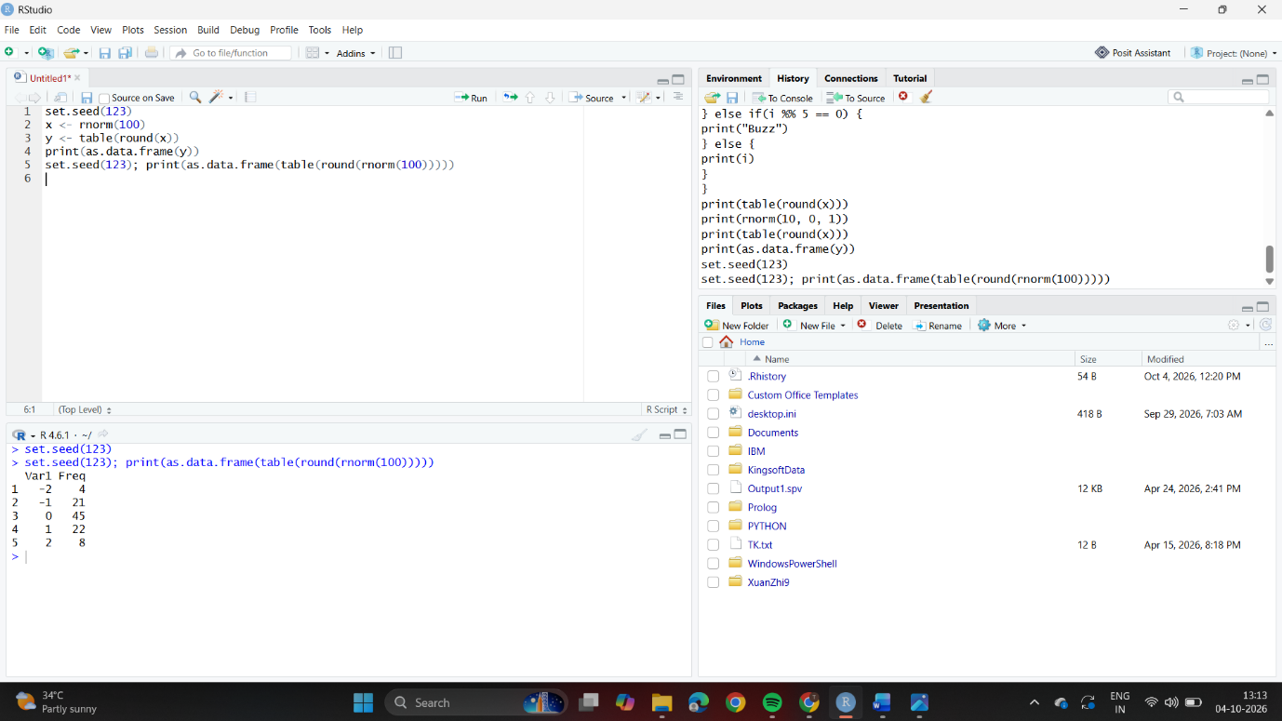
9. Create empty plots with specified axis limits.

Aim:
To create empty plots with specified axis limits.

Procedure
Step 1: Open RStudio or R console on your computer.
Step 2: Remove the variable named c from the workspace using the remove function.
Step 3: Use the plot function to create an empty graph by sefling the type as &quot;n&quot;.
Step 4: Define the range of x-axis and y-axis using xlim and ylim.
Step 5: Label the x-axis and y-axis with appropriate names.
Step 6: Run the program to display an empty plofling area ready for adding points or lines
later.
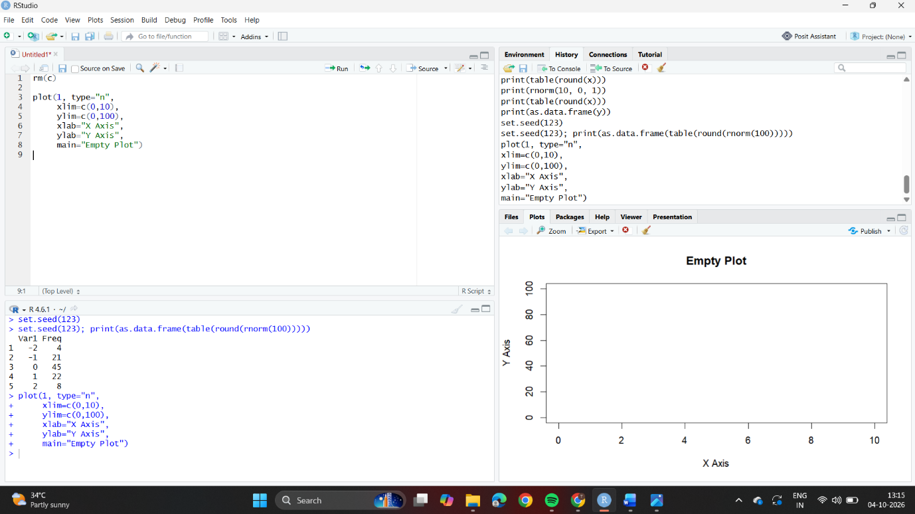
10. Create and explore a data frame exam_data with name, score, attempts, and
qualifying fields. Perform extract, add row/column, sort, save to file.

Aim:
To create and explore a data frame exam_data with name, score, aflempts, and
qualifying fields. Perform extract, add row/column, sort, save to file.

Procedure:
Step 1: Open RStudio or R console on your computer.
Step 2: Create a data frame with student details such as name, score, aflempts, and qualification
status.
Step 3: Add a new student record to the existing data frame using the rbind function.
Step 4: Add a new column named grade to assign grades for each student.
Step 5: Arrange the data in descending order based on the score column. Step
6: Save the final data frame as a CSV file using the write.csv function.
Step 7: Print the data frame to display the updated and sorted student information.

